TO WHOM IT MAY CONCERN

Re: Mr Murali Mohan Besta

Address: 18, Wye Valley Road,

Peterborough PE2 9SP

We confirm that we are acting as accountants for the above named person and his company Tanever Solutions Ltd, Company Registration Number 08248268. We can also confirm that the Company was incorporated on 10th October 2012 and its registered office address is 171 Ballards Lane, London N3 1LP.

Mr Murali Mohan Besta is a director and a 50% shareholder of the company. Mr Murali Mohan Besta takes both dividends and salary from the company and his personal income for the last submitted company accounts up to 28th February 2014 comprised of the following:

Salary - £10,250.92

Dividend - £40,000.00

Based on the accounting records, the company’s turnover for the 12 month period from 10th December 2013 to 09th December 2014 is £115,470.00 including VAT. We can also confirm that the current salary of Mr Murali Mohan Besta is £7,800 per annum.

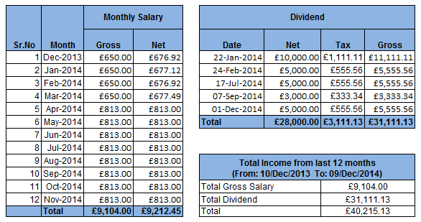

Based on the accounting records, the company’s turnover for the 12 month period from

Faithfully,